Ballard, Kim (2022) The Frameworks of English- Introducing Language Structures, Bloomsbury, Chapters 2-7.
Prat Zagrebelsky, M. Teresa (2023) The English Lexicon: from words to Phraseology, In Pulcini, Virginia (ed.) A Handbook of Present-Day English, Carocci, Chapter 4 (1.4- 1.7; 2.1-2.3 + 2.5,2.6).

**

IMPLICIT VS EXPLICIT KNOWLEDGE OF A LANGUAGE
She goes to school every day
If I would have known about the deadline, I would have submitted the assignment earlier."
I reading a book’

PRESCRIPTIVE VS DESCRIPTIVE APPROACH

Ex. She is not going to the party because she has other plans.
Vs
She ain't goin' to the party 'cause she's got other plans.

**

Definitions of grammar
[Phonetics]
[phonology]
morphology
syntax

Semantics: the meaning

Ex. 1 My best friend has played a trick on me.
Is the prank harmless? What makes you say so?

The next sentence is:
1) I laughed so much I cried!
2)A dirty, rotten trick.

And now?

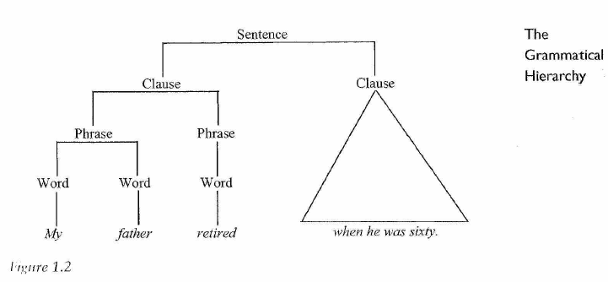

Words

Last night the tall woman watched films at home for three hours.

How many words?

How did we do it?

Lipstick – newspaper – seashell compounds

World power open compound

World-class hyphenated compounds

Put off ; Take on phrasal verbs or multi-word verbs

To beat around the bush idioms
Barking up the wrong tree
Spill the beans

Typical features of a word

- Stop!

2)She had a feeling
a premonition that there would be an accident
she had a pre that there would be an accident

3)I wanted ice cream
Ice cream, I wanted

Lexis: vocabulary of a language
Lexeme:
play, plays, played, and playing = lexeme?

Lexical set:
Cat, dog, tortoise, goldfish, gerbil =
mathematics, literature, history, biology, psychology, sociology=
phonetics, syntax, semantics=
quickly, happily, completely, dramatically, angrily =

HOMONYMY:
a.Sarah was mean to her sister.
b. The mean temperature for the month was 22°C.

a.She went to the bank to deposit her paycheck
b. They sat on the grassy bank, watching the water flow by.

Polysemy:
a. John was a good man. He donated a lot of money to charity.
b. Bill was a good painter. His drawings always were exciting to look at.

Word classes

Category of the word ‘ponytail’: NOUN
Category of the word ‘people’: NOUN
Category of the word ‘toothbrush’ NOUN
LET ME USE YOUR TOOTHBRUSH, PLEASE.
to ponytail her hair VERB ? to people an island?
‘I decided to toothbrush my way into the bathroom’ ?
FUNCTIONAL CONVERSION

Open classes or content words or lexical items or lexemes (4) unrestricted membership
Nouns, adjectives, adverbs, verbs

Closed classes or grammatical words or function words (7)
Restricted membership
Prepositions, conjunctions, articles, numerals, pronouns, quantifiers, interjections

Exercise 1 Lexemes and citation forms
Identify the different lexemes in the following fragment (from The Art of Travel by Alain de Botton) and group them into word classes (according to their function in this sentence) using a dictionary citation form. Make a note of any difficulties or issues you encounter in carrying out this exercise.
On disembarking at Amsterdam’s Schiphol Airport, only a few steps inside the terminal, I am struck by a sign hanging from the ceiling that announces the ways to the arrivals hall, the exit and the transfer desks. It is a bright yellow sign…

Exercise 2 Homonymy and polysemy
For each of the following pairs, decide whether the word forms are connected through homonymy (same word form, two different lexemes) or polysemy (same lexeme, more than one meaning):
 | word form | word class | definition
1a  1b | high  high | adjective  adjective | ‘well above the ground’  ‘having status or rank’
2a  2b | list  list | verb  verb | ‘to compile a written set of items’  ‘to lean to one side’
3a  3b | beam  beam | noun  noun | ‘a long heavy piece of wood’  ‘a ray of light’
4a  4b | skip  skip | verb  verb | ‘to move lightly with little steps and jumps’  ‘to pass over something or leave it out’
5a  5b | perch  perch | noun  noun | ‘a place where a bird sits’  ‘a type of fish’

NOUNS
Ex 1 He painted some beautiful paintings

Ex 2 The majestic mountains stood as silent witnesses to the fleeting beauty of love.

The ‘the’ test

Ex 3 New York City is known for its iconic skyline and vibrant cultural scene. Nouns ?
Ex 4 Alice received a letter from her grandmother, inviting her to a special gathering. Nouns ?
I saw Alice last night.
The Alice I saw was not your cousin.
The Eiffel Tower illuminated the Parisian skyline

however: can you think of some exceptions?

The Alice I know wouldn’t say such horrible things.

The Eiffel Tower illuminated the Parisian skyline with its dazzling lights.

COMMON OR PROPER NOUNS: SAME POSITION

JOHN’S CAR genitive noun
THE FARMERS’ FIELD plural genitive n
CHARLES’S CROWN OR CHARLES’CROWN
THE BABY’S TOYS GENITIVE NOUN FOLLOWED BY ANOTHER NOUN : DEPENDENT GENITIVES
A FRIEND OF SARA’S : GENITIVE NOUN NOT FOLLOWED BY A NOUN INDEPENDENT GENITIVES

Identify and define ALL nouns :
Yesterday, John's friend invited me to visit his sister's house on the outskirts of a quiet town. A friend of John's, Emily, was also present, sharing her ideas about music and art. The energetic child with bright blue eyes played joyfully with several dogs in the large garden. Meanwhile, Sarah stood by a small table alongside a bowl of steaming rice and a cup of freshly brewed coffee.
Later that evening, we dined at a quaint restaurant. A friend of Tom's praised the delicious dishes and fine wine. The attentive waiters, both men and women, served excellent soup and freshly baked bread. The mix of fruits and flour impressed us. Their skilful presentation and creative recipes delighted every esteemed guest.
LEXICAL OR MAIN VERBS

Ex 1 She believed in the power of kindness and actively volunteered at the local shelter.
Nouns?
Verbs? Do they differ?

Ex 2 She owns a vintage car, appreciates classical music, and occasionally dances in the moonlight.
Verbs? Dynamic and stative?

Ex 3 Jane strolls around the park.
They park the car in the park.
She parked the car and then left.

Auxiliary verbs

Ex 1 He should finish his homework before heading out with friends.

- You must finish your homework before heading out with friends.

obligation / permission
Must ; may; can

2 He might/may/could/can’t have forgotten about the meeting.

certainty.

Ex 2 She is watching a movie with her friends.
Ex 3 They have completed their assignments ahead of schedule.

Ex 4 I do believe that practicing regularly will improve your skills.

how do you form questions from Examples 2 and 3?

ADJECTIVES

Ex 1 The vibrant flowers and lush green foliage created a picturesque garden.

REVISION: NOUNS? VERBS?

ADJECTIVES? Attributive position

Ex 2 The cake was moist and delicious.

ADJECTIVES? Predicative position

Seem appear = copular verbs

Ex 3 The extremely talented and exceptionally creative artist showcased a breathtaking masterpiece.
Adjectives? Participial adjectives
Adjectives are gradable

The young need constant care: nominal adjectives

(The) young people need constant care

ADVERBS

Ex 1 She spoke confidently and eloquently during the presentation.

Revision ? nouns? Verbs?

Adverbs work as adjunct

Ex 2 She will arrive at the party later in the evening.

Ex 3 The cat sat quietly, watching the world outside .

Ex 4 The coffee was so hot that I couldn't take a sip without burning my tongue.

Adverbs as disjunct

Ex 5 Surprisingly, the team won the championship.

Obviously, she wasn’t listening.

Ex 6 I finished my work early. Consequently, I was able to enjoy the evening with my friends.

Adverbs as conjunct:

What’s the function of these adverbs?

BOOSTERS DOWNTONERS
Incredibly | slightly
Extremely | Sort of
Remarkably | A bit

PRONOUNS

EX 1 I finished my work early; consequently, I was able to enjoy a leisurely evening with my friends.

Pronouns?

EX 2 The teacher praised herself for her exceptional performance, and she received a special commendation for it.

Reflexive

Primary pronouns : personal, possessive, reflexive

Ex 3 She gave him a book as a birthday gift.

She: subjective pos

Him: objective pos

Ex 4 Though the idea is mine, the success of the project relies on their collaboration.

Mine: independent possessive

Their: dependent possessive

Ex 5 After finishing the marathon, she treated herself to a well-deserved massage.

Ex 6 One can’t be too careful.

Generic Pronoun Formal

You can’t be too careful informal

BUT: Harriet chose a Kenyan safari but Owen preferred a South African one. Substitute p.

Ex. 7 Who is responsible for organizing the event next week?

Interrogative p.: what/ which/ whose/ whom

x. 8 The person who found my lost wallet returned it to the lost and found office.

Relative pronoun : whom/ which/ that

Ex. 9 The winner will receive whatever prize the organizers decide on.

Nominal relative pronoun : whomever, which, whichever, whoever

Ex 10 Everyone should bring something to share, as nobody knows what anyone else is bringing to the potluck.

Indefinite p.

THATs

1 The book that/which I am reading is fascinating.

Relative pronoun:

2 Everyone knows that smoking is dangerous.

Complementizer

3 I enjoyed that book .

Demonstrative pronoun

4 I don’t see him that often.

Adverb: degree

DETERMINERS

Ex 1 All of my friends attended the party, but some relatives couldn't make it.

All of: quantifier

The: def article

Some: indefinite determiner

How to tell a determiner from a pronoun?

1 Is there any food? Give me some! pronoun

2 Give me some food! Determiner

1
The articles the and a/an are used for definite or indefinite reference. Looking at the following paired examples, what else do you notice about their functions? (The relevant parts of the sentences have been underlined.) Some examples have no article – why?

1a  1b | The ambulance rushed the sick woman to the nearest hospital  Hospital is the best place when you’re that ill
2a  2b | Be careful of the ice on the path  Ice can be so dangerous in winter
3a  3b | The dinner was delicious  I’ll see you later for dinner
4a  4b | When did you last get to see a movie?  Have you ever seen a movie directed by Ken Loach?
5a  5b | I need to go to the dentist  I need to go to a dentist
6a  6b | Can you see the moon tonight?  Do you know if Saturn has a moon?

2
Consider the meanings provided by the determiners in the following underlined examples:
Ron was a man of few words
Could you give me a few ideas for my holiday?
I’d appreciate a little sugar in my tea
I’d appreciate a little biscuit with my tea
Sadly, this excellent charity receives little attention

PREPOSITIONS

Ex 1 She walked through the park and then sat by the fountain.

?

Ex 2 I will meet you at the restaurant at 7 o'clock for dinner.

Complex prep According to; on behalf of, with regard to

Ex 3 The keys are under the mat and the spare ones are hidden behind the plant.

Ex 4 I’m going to London

Don’t forget to lock the door.

careful:

She was writing until midnight/ I’m not going until my essay is done

CONJUNCTIONS

1 I like to read mystery novels, and my sister prefers fantasy books.

2 You can have ice cream or cake for dessert.

3 She wanted to go to the party, but she had to finish her homework.

Coordinating conj

vs

4 If it rains, we'll have to cancel the outdoor picnic.

5 Since it was a holiday, the office was closed.

6 We postponed the event because of the unexpected power outage.

Subordinating conj

as long as

as soon as

as though

provided that

Exercises

Identify which classes (major and minor) each of the following word forms belongs to:
Well : adjective;adverb; noun; interjection; verb (tears welled from her eyes)

Slow: adjective; verb; (adv)

Blast: noun; verb; interjection

Better: adjective; adverb; The organization was established to better conditions for the disabled.

Whatever: interj; pronoun;determiner

Fast: adjective; verb; adverb; noun

If: conjunction; noun (Let’s go through all the ifs and buts of your argument)

Round: adjective; verb; noun; adverb; preposition

The dog ran round (prep) the table; My neighbour came round(adv) to see me
Rash: noun; adjective

Will: modal auxiliary verb; noun;

Sentence Analysis: Provide sentences with missing words + identify the missing word class.

1 _det(the = def art)__ curious cat quietly ____Verb _ through the garden, searching _prep__ hidden treasures.

2 _Sub conj__ the heavy rain, the dedicated NOUN (HIKERS) continued POSS PRON (THEIR) journey up the ____NOUN (HILL).

3 After the adj (long) ride, Sarah felt a mix prep (of) excitement coord conj(and) relief.

.

4 The ancient NOUN (book), with poss pron (its) worn pages and faded ink, verb (held)the secrets of a forgotten era.

5 His story verb (is) a adv (very) romantic one, (and)coord conj it ___has (primary aux verb)_____ inspired many(determiner - quantifier) Hollywood movies.

Exercise 2

Meaning of the underlined adverbs

1 The choir sang beautifully .manner

2 We’ll meet outside after the concert.place

3 Amy tries really hard to be popular. manner

4 Strangely, no one answered the phone. (disjunct) stance

5 He felt that he had been unfairly treated. manner

6 Hopefully, no one was injured. (disjunct) stance

7 You can’t park here. place

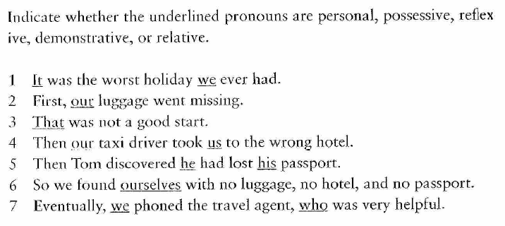
1: it: pers pron; we: pers pron . 2: possessive pron; 3:demonstrative p; 4: poss +personal.
5:pers + poss; 6:reflexive; 7:personal + relative p

WORD FORMATION

Definitions of grammar
[Phonetics, sounds]+[phonology, syllables and intonation]+morphology+ syntax = Semantics

Morphology: the internal structure of words

***

Definitions of morpheme: smallest unit of meaning
free morpheme:
Dog

Run:

Happy
*
Derivational morphology: word formation through affixation and compounding to change meaning
Ex happy unHAPPY

Inflectional morphology: grammatical info on the word
Ex. PLAY PLAY-S

Can new have both?
Resignations = Resign + ation (derivational) + s (inflectional).

root vs base:
1 origin: root = origin-al (ADJ)
2 original: base for original-ly (ADV)
-LY : DERIV SUFF
ORIGINAL : BASE
ORIGIN : ROOT

free (F) vs bound (B) morpheme:

1 u n (B)/ f r i e n d (F) / l y (B) ADVERB; UN= BOUND MORPHEME, PREFIX; LY: BOUND MORPHEME SUFFIX; FRIEND = ROOT; FRIENDLY

2 p r e (B) / o r d a i n (F) / e d (B)?

3 u n / in t e r e s t / i n g ?

Bound morphemes or affixes: prefixes (beginning) and suffixes (end)

Prefix: CLASS-PRESERVING
un/ friendly

de/clutter

what word class?

Polite : the contrary? IM/POLITE

Legal: IL-LEGAL

Definite: IN-DEFINITE

Allomorphs: DIFFERENT REALIZATIONS OF THE SAME ABSTRACT MORPHEME

dis- reverse of
in- opposite of, lack of,
mis- incorrect, wrong

un- opposite of,

suffix: THEY CAN BE CLASS-CHANGING
- Friend 1.1) friend-ly
- Implement 2.1) implement-ation

king 3.1) kingdom THEY CAN ALSO BE CLASS-PRESERVING + OCCURRING WITH ONE CLASS

-let small version of DROPLET; PIGLET
-al from verbs, often an action ARRIVAL
-ant from verbs, performing an action
-ation process or result of an action

-ee a doer or receiver of an action
-er person/thing that does

-ment result, purpose
-ness a quality of something

Morphemes should not be confused with syllables

Ex 1
Break the following complex words down into morphemes. Identify whether the morphemes are free or bound. Are the bound morphemes affixes or roots?
Perch (f)/ er (B),
Perish (F) / able (B), (ADJ)
Perk (F) / y (B), ADJ
Persian, PERSIA (F) + IAN (B)
personal,

Word formation
Reading is an important (1) ACTION (act) that helps people develop their knowledge and imagination. It can be both (2) EDUCATIONAL (education) and entertaining. Many studies suggest that reading regularly improves (3) CONCENTRATION (concentrate) and even helps to reduce stress.
In today’s world, people are often too busy to read books, but there are many (4) POSSIBILITIES (possible) to include reading in daily life. For example, listening to audiobooks while commuting is a (5) USEFUL (use) way to enjoy literature.
Children should be encouraged to read from an early age because it has a (6) BENEFICIAL (benefit) effect on their language skills. Parents and teachers play a (7) SIGNIFICANT (significance) role in creating a habit of reading.
Reading different types of books can also make people more (8) CREATIVE (create) and open-minded. It allows them to see the world from different (9) PERSPECTIVES (perspective).
In conclusion, reading is a simple yet (10) POWERFUL (power) activity that can improve many aspects of life.

Technology has brought many (1) ADVANCEMENTS (advance) in recent years, making our lives easier and more (2) COMFORTABLE (comfort). From smartphones to artificial intelligence, (3) SCIENTIFIC (science) discoveries continue to change the way we live and work.
One of the most (4) IMPRESSIVE (impress) developments is the internet, which has improved global (5) COMMUNICATION (communicate). People can now share ideas and information (6) INSTANTLY (instant) and access a huge amount of knowledge with just a few clicks.
However, technology also has some (7) DANGERS (danger). Spending too much time on electronic devices can be (8) HARMFUL (harm) to both physical and mental health. It is important to find a (9) BALANCED (balance) APPROACH between using technology and spending time on other activities.
Despite some challenges, technology will continue to play a (10) MAJOR (majority) role in shaping the future of society.

COMPOUNDING

landlord blackboard overdose scarecrow

Compound words or compounds

Variety of combinations
 | Noun | Adjective | Verb | Adverb
Noun | daylight | garden-fresh | handmade | passer-by
Adjective | greenhouse | bittersweet | good-looking
Verb | pickpocket |  | would-be | know-how
Adverb | overcoat | evergreen | underestimate | henceforth

Conversion
I got this email from my boss / I mustn’t forget to email her
Go buy some butter / Don't butter the bread for me. I prefer jam.

Back formation

Edit (from editor):

Donate (from donation):

Resurrect (from resurrection):

Deduct (from deduction):

Clipping
Ad (from advertisement);
Lab (from laboratory);
Exam (from examination);
Math (from mathematics);
Pic (from picture)
Fam (from family)
Bio (from biology)
Doc (from doctor)
Blend - blending
Brunch – breakfast + lunch
Smog – smoke + fog
Brexit – Britain + exit

Acronym
NASA : National Aeronautics and Space Administration
UNICEF: United Nations International Children's Emergency Fund
NATO : North Atlantic Treaty Organization
PIN : personal identification number

Initialism or abbreviation

USA: United States of America
BBC: British Broadcasting Corporation
CEO : Chief Executive Officer

Onomatopoeia and eponymy
1
Buzz : The sound of a bee.
Meow: The sound a cat makes.
Boom : The sound of an explosion.

2 Eponymy
Sandwich - noun:
Boycott - verb:

EX 1:
FLAMMABLE
INFLAMMABLE

HABITABLE:
INHABITABLE

Syntactic
syntactical

Ex 2: Neologisms
For each example, identify the word formation strategy used to form it
bromance, brother + romance = blending
BYOD, bring your own device = initialism
emoji, = loanword (prestito)
FOMO, = fear of missing out = acronym
google (verb) eponym
locavore, = local + vore compounding
Rooneyesque (adjective) =

Ex 3: The meaning of -er
MEANING 1: THE DOER
MEANING 2:
-something inanimate is carrying out a process or action. Beeper, immobiliser juicer stapler toaster, volumiser,

- status or membership A-lister teenager
- origin or nationality New Zealander
-when, where or how someone does something nine-to-fiver off-roader YouTuber
-a feature or quality of something forehander no-brainer

INFLECTIONS

REVISION
morpheme
free (root) | bound (affix)
free (root) | prefix | suffix
free (root) | derivational and  class-preserving | derivational and  class changing | inflexional and  non-class changing

inflections as part of grammar

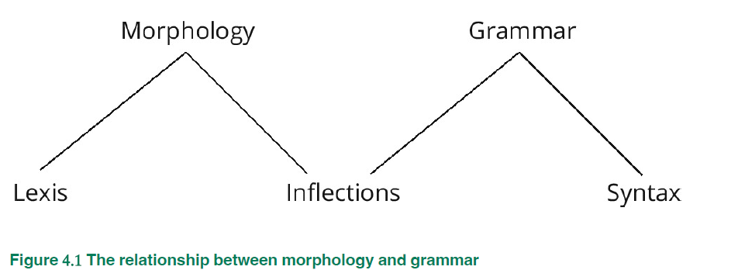

never results in the creation of a new lexeme

REGULAR VS IRREGULAR INFLECTIONS
noun inflections

boats apples peaches
1)Plural morpheme {s₁}

VOICELESS VOICED SIBILANT
boats /-s/ apples /-z/ peaches /-iz/

An exciting game was taking place on the beach
Some exciting games were taking place on the beach
non-count nouns: concrete (hockey, music, furniture) ; abstract ( misery, hatred, amazement)
a game ; *a hockey

linguistics

IRREGULAR noun plurals and inflections:
1)Zero inflection: singular form = the plural form
sheep / sheep
2 ) vowel mutation:
man /men
- voicing of final consonant: a regular -s plural is added but the last consonant is pronounced with a vibration of the vocal chords
knife / knives

- irregular plural inflection from Old English
child / children
*

The cat’s tail was fluffy.
2) possessive inflection{s₂}
My friend’s house

possessive inflection vs possessive meaning
hard day’s work
the journey’s end = the end of the journey

The teacher spoke to Chris and Jonathan’s mother about their behaviour
Who is the possessive inflections referring to?

noun possessive -s of-construction

1 the possessive -s inflection are used to indicate relationships other than simply possession (for instance, duration, as in a hard day’s work). Using the examples below, identify further uses

yesterday’s prices
New Zealand’s mountains / the school’s ethos
the scientists’ discovery / Toni Morrison’s fiction
the Queen’s coronation
an idiot’s course of action

verb inflections
d e n a t i o n a l i s e d
denationalised
derivational prefix | root | derivational suffix | derivational suffix | inflexional suffix {ed₁} or {ed₂}
de- | nation | -al | -ise | -ed

missed ended
ed: Past tense morpheme {ed₁} and past participle morpheme {ed₂}
saved /-d/ missed /-t/ ended /-id/

irregular verbs may have different forms for the ed- past tense and the -ed past participle
I spoke vs I have spoken.

*

walks runs chases
Present tense third person singular morpheme {s₃}
walks /-s/ runs /-z/ chases /-iz/
allomorphic variation

*
walking running chasing
ing participle{ing}

*

Adjective/adverbs inflections
- This house is bigger than the one next door.
- Her garden is the most beautiful in the neighbourhood.
{er} {est}

More and most : periphrastic, premodifying adverbs
fast - faster - fastest / deeply -more deeply -most deeply

Irregular forms for good and bad: suppletive forms
Better- best
Bad – worse – worst

*
Singular noun | Irregular plural | Type of plural | Can regular plural be used?
cactus | cacti | Latin plural | yes – cactuses
appendix | appendices | Latin plural | yes – appendixes
bacterium | bacteria | Latin plural | no
criterion | criteria | Greek plural | no
datum | data | Latin plural | no/rarely – datums
fish | fish | zero inflection | yes, sometimes – fishes
goose | geese | vowel mutation | no
kibbutz | kibbutzim | modern Hebrew plural | yes – kibbutzes
mouse | mice | vowel mutation | yes, sometimes – mouses
stigma | stigmata | Greek plural | yes – stigmas
syllabus | syllabi | Latin plural | yes – syllabuses

Phrases

Syntax: combination of words in smaller units

How many sentences?
phrases?
words? morphemes?
Rankscale represented through a tree-diagram

S

P
W
M

Phrases are a sequence of word groups

the five types of phrases
(noun, verb, prepositional, adjective, adverb): what class?

- Peter NP| was VP | extremely anxious adjp | on Friday morning PP|.

- The tall woman NP | walked VP | out of the building PP | into the rain PP.

- She NP| finished VP | her work NP| very quickly.ADVP

The Noun Phrase
Noun phrase = obligatory nominal head + optional determiners + optional modifiers
DET + PREMODIFIER + HEAD + POSTMODIFIER
How do we identify the head?
1 number test Ex. ‘a slice of melon’ – ‘two slices of melon WERE ON THE TABLE
2 Ex. The boy in the car NP| is | my son NP.

These large sugary doughnuts filled with jam and cream | are | really fattening

Determiners:

- Def-indef articles: a/an; the
- Possessive pronouns: my, your, his, her…
- Genitive nouns: Amy’s CAR
- Demonstrative pronouns: this, that, these, those
- Interrogative pronouns: what, which (when introducing questions)
- Nominal relative pronouns: whatever, whichever
- Quantifying pronouns: all, both, every, few
- Numerals: one, two, third,

+
Modifiers:
Premodifiers:
- Adjective: ‘crazy people’
- Noun: ‘tv programme; computer screen’; BEHAVE LIKE AN ADJECTIVE;
- More than one noun: ‘internet service provider’.

Ex 3 The strong people in the room | will move | the desk

POSTMODIFIER?

Ex 4 the bleak landscape covered in snow | caught my eye

POSTMODIFIER?

Ex 5) clearer instructions than those you gave me

POSTMODIFIER?

6)The intricate detail of the ancient manuscript, filled with delicate illustrations and meticulously written text, has captured the attention of the historian studying the medieval period.

Np?

7)William Shakespeare, the author of Hamlet, died in 1616

8) For supper Lloyd cooked salmon fillets and new potatoes

Exercise : phrases and compound words: For each of the following pairs, analyse the elements in capital letters, identifying the compound words (one in each pairing) and making clear the

structural differences between the pairs.
1a | His umbrella dripping, he rushed into the office in A WET SUIT
1b | He arrived at the beach dressed in A WET SUIT
2a | I prefer regular milk to THE LONG LIFE VARIETY
2b | Healthy living is the key to A LONG LIFE
3a | They were READY TO WEAR CLOWN COSTUMES at the charity run
3b | They bought THEIR READY TO WEAR CLOWN COSTUMES at the party shop
4a | Joe bought HIS ROUND TABLE in the January sales
4b | The children loved the stories of King Arthur and HIS ROUND TABLE

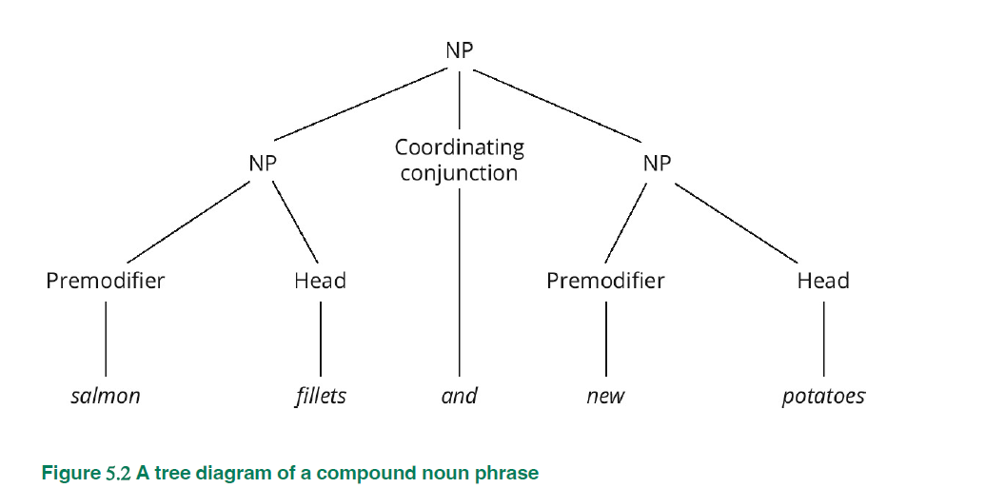

Adjective phrases

Adjective phrase = obligatory adjectival head + optional modifiers

The door is green

The hungry cat was looking extremely aggressive
Premodifiers?
My new shoes felt incredibly uncomfortable
Premodifiers?

postmodifiers:
Things are apt to go wrong
?
Everybody’s fond of chocolate

?
Your work was good enough/good indeed

?

EMBEDDING

[a [rather nice AdjP] invitation NP]
Adverb phrases

Adverb phrase = obligatory adverbial head + optional modifiers

Bevis frequently mends his car

We can celebrate afterwards

The team played well enough
The team played (very) skilfully indeed

The Prepositional Phrase
on the boat
behind the bus
on Friday night

Prepositional phrase = obligatory Head (simple or complex preposition) + obligatory Prepositional Complement (usually NP or non-finite clause)

- Sam sunbathed BESIDE a stream

2)Sigmund was an auctioneer for three years

What does the prep phrase do in these examples?
I’m experiencing great anxiety about the future

She was not interested in the offer

Can prep phrases be modified?

this happened just opposite the flat
this happened a month before her departure
this happened some time after the election

How to understand when PP postmodify nouns

1 Clive gave Kate a (DET; indefinite article) large(PREMODIFIER; adjective) bouquet of roses (POSTM; PREPOSITIONAL PHRASE ; OF + PREP COMPLEMENT ; NOUN PHRASE ; ROSE root + inflectional morph -s)

*Of roses Clive gate a large bouquet : POSTMODIFIER IN A NOUN PHRASE

2 Heidi (NP;proper noun)| cycled (VP)| fifty miles(NP; deter- numeral; ) | for charity (PP; Prep + prepositional complement NP). For charity, HEIDI CYCLED 50 MILES

The Verb Phrase
Revision : verbs ?
LEXICAL VERBS
AUXILIARY VERBS : primary aux (be ; have ; do)
Modal aux v (can/could ; shall/should ;will/would, etc)
Be going to

SIMPLE VP
I drink
I sleep

COMPLEX VP:
may have sat
can’t have been singing
have been drinking

Verb phrase = optional auxiliary verbs + obligatory lexical or main verb

Adverbs and Verb Phrases
1 The children | have |certainly | been told off |DISJUNCTS after the first aux
2 The children have been severely told off. MANNER before the lex v

The Grammatical Features of the Verb Phrase

- She speaks vs. she spoke
TENSE : present ; past

Grammatical form and tense in the verb phrase vs meaning
1 Sport | appeals | to many people present tense for undefined time
2 She arrives tomorrow present tense; future time
Is coming : tense is marked on the first element of the verb phrase

What about the future? Future TIME, NO FUTURE TENSE.

Ways to express future?
- Present tense: She arrives tomorrow
2)modal auxiliary will : will arrive
3) she is going to arrive:
4) she is arriving

- ASPECT

1 has gone will have given could have delayed PERFECTIVE ASPECT: have + ed2

2 Was coming is procrastinating would be cooking PROGRESSIVE aspect be + ing

Order?
Modal + primary be, have, do + lex v
Will have given;
Will go

ASPECT + TENSE
=
PRESENT PERFECT I have studied
PAST PERFECT I had studied
Aux have + lex v + ed₂

PRESENT PROGRESSIVE we are learning
PAST PROGRESSIVE you were teaching
Aux be + lex verb + ing form
the verb aspect can be both perfect and progressive,
present perfect progressive Debra has been gardening
past perfect progressive Debra had been gardening

3. VOICE
Everyone| dreaded VP ; |Jim’s stew (active), vs. Jim’s stew | was dreaded VP | (by everyone)()passive

PRIMARY AUX BE + ED₂

Aux be + ed₂
SO: aux be and progressive aspect = ing participle
Aux be and passive voice= ed₂ participle
The song was being performed

- Contrast

Finite vs non finite
I want some tea
Tense? Present

1.To get| home early
To gets
To have arrived | on time was their objective to has arrived

Tense?

Base form without to: ex Susan helped (vp1) wash up (vp2)

2.Hurt, he left the room.
Ed-form
3.Believing him, she didn’t speak
Ing-form

4. Mood

Jill picks up the ball, indicative
vs.
Jill, pick up the ball!, imperative

vs.
I request that Jill pick up the ball subjunctive

5. Concord or agreement

The woman speaks The women speak

to speak, speaking, spoken:
Non-finite VPs are marked only for aspect and voice

She speaks vs.
She spoke, speak (she), I speak:
Finite VPs are marked for aspect, voice, tense, mood and concord

Ex 1: analyse the following VP

1)has bullied:

Has= primary aux; have + -s inflectional m

Bullied=lex verb; bully + ed₂ inflectional m

Tense: present.

Aspect: perfective

Voice: active

Mood:indicative

- am feeding

Am= prim aux

Feeding= lex verb; feed + infl morph -ing

Tense: present;

Aspect: progressive

Voice:active

3)was being discussed

Was prim aux be

Being prim aux be –ing morph

Discussed lex v + ed₂

Tense: past

Aspect:progressive

Voice:passive

2 Change the verb phrase in the following sentence as specified

The students protest about funding in education

1 present tense, progressive aspect are protesting

2 past tense, perfect aspect had protested

3 progressive aspect with modal could could be protesting

4 past tense, perfect progressive aspect had been protesting

5 past tense protested

3 Identify the time reference of the underlined present tense verb(s) and the possible context in which the example might occur:
1 A horse goes into a bar and orders a drink
2 If you go to London next week, I can meet you there
3 According to her message, I gather she has already left
4 Pensioner wins lottery millions
5 Shakespeare uses many references to the natural world in his plays
6 The exams finish tomorrow
7 It’s good that you eat an apple every day

ANALYSE THE FOLLOWING PHRASES

1 My best suit (H) NP

MY= DET; poss pron

BEST= PREM adj

2 Every boy (H)who has read the article NP

EVERY= DET quantif

who has read the article : POSTM

-who: relative pronoun

-has read VP,TENSE: PRES; ASPECT: PERFECT; VOICE: ACTIVE

-THE ARTICLE: NP

- Doubtful about the result of the experiment ADJ PH

about the result of the experiment: POSTM ; prep ph;

Doubt (root)-ful derivational suffix

very impatient

Loyal to the company and to his friends

**

SHE TREATED HIM VERY UNFAIRLY.

*

AMY LIKES READING NOVELS

*

THE COMMITTED INSISTED THAT SHE RESIGN IMMEDIATELY

*

YOU CAN IMAGINE HIS JOY WHEN AT LAST THE SHIP CAME IN SIGHT OF HIM
The Clause
Clauses from phrases

1 The bowler (NP) threw (VP) the ball (NP) at the stumps (PP).
Phrases?

2 You NP | like VP| the book that she is talkingVP about.|
Phrases?
Verb phrases? 2
Clauses?
Words + words = phrases; phrases + phrases = CLAUSES

Clause elements
Clause elements indicate Functions
Phrases indicate Form
What main functions do you know?

1 The cat NP – SUBJECT
| chased VP |VERB
the mouse NP. OBJECT

SUBJECT :

Before the verb. SUBJECT POSITION: NOT necessarily the first element!

1 Although she was tired, Amy kept studying.
It is going to rain.
There will be a storm tonight . DUMMY SUBJECTS
*
How to identify the subject
1 The inversion test (only verb to be).
James is at school.
Is James at school?

2 The tag question test
Paul is getting big, ISN’T HE ?

Be refers to Paul

The children seem busy, DON’T THEY?

Tag question test useful for complicated sentences
THERE was a storm last night, WASN’T THERE?

- subj verb agreement
the dog barks
the dogs bark

VERB FUNCTION
V= vp
1 Paul arrived.
2 Paul planted A TREE
PREDICATE: VERB + COMPLEMENTATION

OBJECT FUNCTION

3 Paul planted a cherry tree.

verbs + O= transitive verbs;

*

I gave my friend a book.
my friend : O_{I} - IO
a book : O_{D -} DO
IO IS THE ONLY ONE THAT CAN BE TURNED INTO A PP : TO MY FRIEND
verbs + 2 x O= DITRANSITIVE VERBS
*
verbs without O= intransitive

*
O can be:
1:The cat chased the mouse = O is NP
2:I SUB| hope V | that you [S] have[V] a great day[DO] DO.= O is A CLAUSE

SUBJECT AND OBJECT COMPLEMENT

verbs requiring complements rather than objects

1 She IS/SEEMS/APPEARS/ FEELS happy.

seems = COPULAR VERB
happy= SUBJECT COMPLEMENT

The cake is delicious.
Be=
Delicious refers to? subj compl C_{s}

*
She [S] became [V] the company director. SUBJ COMPL - NP

She [S] was [V] in a difficult situation SUBJ COMPL - PP

I S| found V| the room DO | quite messy . OBJECT COMPLEMENT

ADVERBIALS OR ADJUNCTS

Sarah [S]| completed [V] her work on the project [DO] | with impressive efficiency.[A]
NP
PROPER NOUN

completed [V]- VP ; LEX V PAST TENSE-ACTIVE VOICE- ROOT COMPLETE + INFL MORPH ED₁
her work on the project [DO]: NP DET + H + POSTM; PP

with impressive efficiency.[A]: PP

1 Terry S| put V| the rubbish DO O_{D}| in the dustbin.

2 Terry S | putV| the boat DO| in danger.

Adj or OBj complement?

The rubbish is in the dustbin ok BUT seemed in in the dustbin? looked in the dustbin? NO
The boat is in danger – the boat seemed in danger – the boat looked in danger

CLAUSE STRUCTURE
S V
I’m going

S V O
She ate an apple

S V O_{i} O_{d}
She gave her brother a thoughtful gift.

S V C_{s}
The cake tasted delicious

S V O C_{o}
She painted the wall green

S V A
The flowers bloomed beautifully

S V O A
He read the book attentively
Practice
Identifying functions

- Recently, finding a job has become very difficult: S
- Amy sings very sweetly: A
- I've left my keys in the car : Od
- Robert promised me that he'd send a postcard: Oi; Od

- You - can put - your coat - in my bedroom .
- You - have made - me - very happy .
- She - has learned - by heart - most of the Old English declensions and conjugations.

- The older child feeds the younger ones.

- The child cried when he hurt himself badly
- The bomb-disposal squad was called by the police.
- The police called the bomb-disposal squad.

- I dusted the bookshelf in my bedroom.
- Sandra recorded the adverse effects of the changes.
- Carter may have photographed light bulbs lately.e
- She phoned us this evening while we were having dinner.
- A university must be a community of scholars.
- The protestors were demonstrating noisily outside the building of the FBI.

ACTIVE AND PASSIVE

The chef cooked a delicious meal.
Active? Why?

Passive transformation?

---

what happened?

NON-FINITE CLAUSES

1 She decided to take a trip to the mountains. DO

2 She watched the sunset, feeling a sense of peace. ADJUNCT

3 Finished with her work, she left the office. ADJ

1 Main (independent) vs subordinate (dependent) clauses

2 Clauses can be subjects or other elements

The aim was to explore the area.

To study algebra is difficult.
-nominal clause

Tim wants to start a theatre company.

Treated kindly, the puppy will be good .

[I believe] [that he will arrive on time.]
MC SUB C

That-clauses
For NP and ADJP; finite verb
NP: The belief
that God exists SUB CONJ + SUBJ+
drives my decisions.
ADJ PH: I’m glad (THAT) you came.
WHAT POSITION IN THE NP?

Comparative clause

1 Victoria got better grades than her sister got. NP

2 Louise is more talented than her friends are. ADJ P

3 Louise is AS talented AS her friends are.CORRELATIVE SUBORDINATORS

Wh- clause
1 [I wonder ] MAIN
[what time the train will arrive.] SUB CL
2 I wonder which way to go.
3 The problem of how they would raise money S | kept V | him DO | awake.

Relative clauses
WHO, WHOM, WHICH, THAT
1 The woman who [REL PRONOUN] lives V next door ADJ| S
is V
| a talented artist.SUBJ COMPL

2 the prize, which was generous, had been won twice.

3 The man (that/whom) I saw was wearing gloves.
zero relative pronoun

4.1The student who is submitting the report is diligent.
4.2 The student submitting the report is diligent.
reduced relative clauses

Nominal relative clauses
what, whatever, whoever, where , how: WH WORDS
appear where NPs should be

What you need is some sleep.
you need some sleep: unmarked structure.
marked structure.

He asked what had happened.
what had happened . unmarked.
What had happened he asked. Marked FRONTING

Negative clauses
1 Ravin is not a good manager.

2 Emma might not come home.
3 Louise did not like the film dummy operator.

4 He told me never to do it again. adverb
5 It really is no use. determiner
6 She said nothing about a trip to America. pronoun

Identify the clause structure of the following examples and label the elements using S, V, O, C, A. Are there any instances of embedding?
1 | Bradley Wiggins has won the most prestigious race in cycling
2 | Jo is feeling better today
3 | I think they’ve arrived by now
4 | The pyramids of Egypt are much bigger than I imagined
5 | The woman who lives next door showed me her new greenhouse

The sentence

Barry likes football.
Simple sentence: none of the functions is realised by a clause

Always an independent sentence

But

conjoins

Jim likes wall flowers and Penny loves magnolias.

COMPOUND SENTENCES
Compound sentence (coordination): the linking of two or more clauses
Each of the clauses is independent

The explosion came unexpectedly but no one was killed.
Syndetic coordination

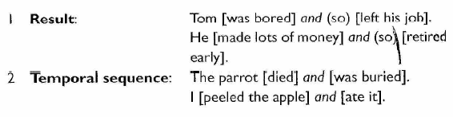

Jim came through the door, Bill went out of the window.

Asyndetic coordination

He talks and (he) walks and (he) drinks.
Polysyndetic c.

Correlative pairs: either/or
Either Gregory will cook the dinner or Clare will fetch a takeaway. (clauses)
Gregory will cook either fish or rice. (phrases):
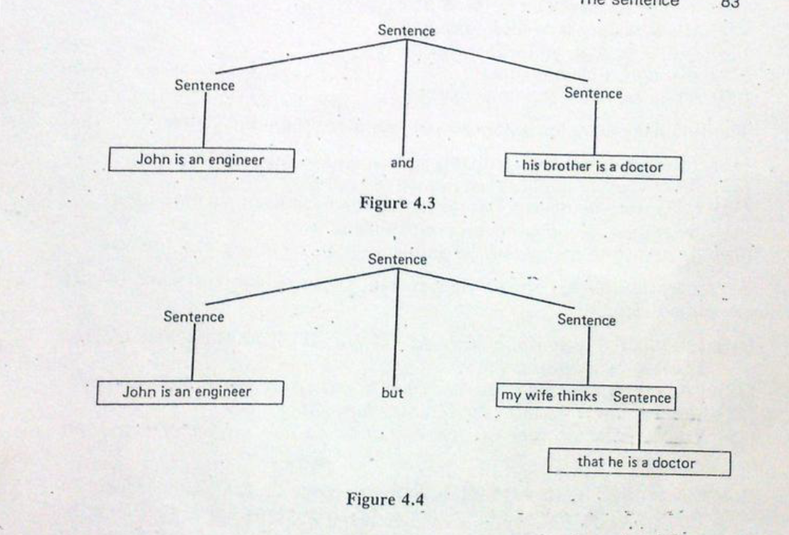

COMPLEX SENTENCES
Complex sentence (subordination): the use of a clause as a function/element in the structure of a sentence

1 When Ruth arrives (ADJ), I(S) might open (v) a bottle of wine (DO).

2 Today (adj) I(S) might open (v) a bottle of wine (DO).

Clause?

The embedded clause is subordinate or dependent
Main clause vs. subordinate or secondary clause

The possibility is that Jim is scared of water.
Finite subordinate clauses with a finite VP
Realise main clauses as well as secondary clauses

Clause?

She doesn’t seem to suffer much
Non-finite subordinate clauses with a non-finite VP(to infinitive)
Realise secondary clauses only

Alissa watched her friends play tennis.

Non-finite subordinate clause: bare infinitive.

Subordinate clauses as adjuncts

Manner + place + time

Condition (sub conj: if; unless; as long as)
If it rains tomorrow, we will reschedule the outdoor event.
Unless you finish your homework, you won't be able to join us for the movie tonight.
+
Concession (although; while; though)
Despite raining heavily, they decided to go ahead with the picnic.
Although she was tired (ADJ), she (S) continued (V) working on her project(DO) to meet the deadline (ADJ).

+

Reason (because; as; since)
He didn't attend the party because/as/since he had an early meeting the next day.
Since she wanted to improve her overall health, she started exercising regularly.
+
Purpose (in order to)
He bought a new laptop (in order) to work more efficiently.

+
Result (so; so that)
She changed the tape so that she could see the movie
*

As she walked into the Embassy, she was shot.
Did she tell you who was coming?
Subordinate clauses also introduced by subordinators and by wh-pronouns

If Danielle likes the book, she should buy it

Substitution

She eats in a local snack bar and occasionally in a restaurant

Ellipsis
Sentence types

She should have opened that window.
Positive sentence

She should not have opened that window.
Negative sentence

Positive and negative sentences are declarative sentences (Su + Aux)
*

Who should have opened that window?
Interrogative sentence - wh-question (interrogative pronoun in initial position)

Should she have opened that window?
Interrogative sentence - yes-no question (Aux + Su, subject – operator inversion)

She should have opened that window, shouldn’t she?
Interrogative sentence - tag question (declarative + interrogative)

Did you open that window?
Interrogative sentence – do operator primary aux
*

Open that window!
Imperative sentence (imperative mood)

*

How decorated that window is!
Exclamative sentence (wh-phrase + Su + Aux)
What and how

No one-to-one correspondence between the grammatical structure of a sentence and its function in communication

The Sentence and the Organisation of the Message

Robert is driving to London
Given vs. new: end-focus

ROBERT is driving to London
Robert IS driving to London
Robert is DRIVING to London
Robert is driving TO London
Contrastive focus: stress

I don’t like alcohol
Alcohol (DO) I don’t like
Fronting
Unmarked word order vs. marked word order

It is common knowledge that Jane is changing jobs.
(that Jane is changing jobs is common knowledge)
Extraposition: Dummy subj it/anticipatory it + copular verb

My mother was responsible for all this.
It was my mother who was responsible for all this.
It + be + focus + relative clause = cleft sentence

The children need discipline
What the children need is discipline
= pseudo cleft sentence

There has been an accident.
Existential there

*

Words and knowledge
Lexical competence
Receptive or passive vs. active or lexical competence:
What knowledge is necessary to know a word?
1 pronunciation
2 parts and grammatical function
3 connotations
- patterns and collocations: frozen vs restricted()
- register, formal or informal contexts.
General language vs specialized language
Lexico-grammar : the full range of linguistic contexts and uses of the word.

How to learn : dictionaries
Bilingual vs monolingual; native vs learners’;
OED; most comprehensive, diachronic overview and inclusion of new words: neologisms vs occasionalisms;
Learners’ dictionaries provide more info: spelling, word class, examples of usage depending on the different meanings,

Corpus linguistics computational linguistics
https://corpus.byu.edu/

humid vs damp vs moist KWIC

lexicogrammar: Halliday. Lexis and grammar are no longer separated;
two principles in language: 1 open choice; 2 idiom principle.

The nature of English lexicon

Germanic language but ‘dissociative’ character :
Word of Anglo-saxon origin 40%: monosyllabic, short, referring to every day life. House, food, come, see, good, old, new
Words of LATIN ,GREEK and Romance origin: polysyllabic words, more specialised and formal contexts. Thanks to translation because Latinate terms added a more refined character to English texts
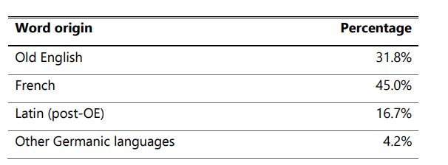
before/prior

abdomen vs belly;
The implants are fitted under the skin of the abdomen, directly above the stomach.

a feeling vs sensation.
She must have caused a sensation among her relatives.

timid vs shy,
She had a weak and timid handshake.

forest vs wood
isle vs island

dormant vs sleeping

happy vs felicitous

Mistake ‘He’d made the mistake of going against his gut instincts’. Vs error ‘a mathematical error’

False friends
Actually, agenda, argument, attitude, brave, commodity, consistent, delude, director, disgrace, dramatic, editor, educated, eventually,

Register and tenor

*
Fluency and appropriacy depend on mastering phraseology: stable word-groups
1 Greetings, politeness formulae. Importance of Pragmatics:

Pass the salt, please.
Can you pass the salt, please?
Will you pass the salt, please?
Could you pass the salt, please?
Would you mind passing the salt?

2 COLLOCATIONS
3 IDIOMS Break a leg; Call it a day; to go Dutch; cut corners; That's the last straw; Get out of hand; Give someone the benefit of the doubt;

Sapir Whorf hypothesis: cultural relativism, language describes culture.
Language changes depending on the new needs.

S - Simple Sentence
Main cl : Fin. cl
Su. : NP | P : VP |  | SC : NP
H : Pers. pro | LV (Cop) |  | Det : Pos. pro | H : N | Pom : Fin. cl
It | was |  | my | mother | Su. : NP | P : VP |  | SC : AP
 |  |  |  |  | H : Rel. pro | LV (Cop) |  | H : A | Pom : PP
 |  |  |  |  | who | was |  | responsible | Prepos : P | Prepos. C : NP
 |  |  |  |  |  |  |  |  | for | Det : Quant | H : Dem. pro
 |  |  |  |  |  |  |  |  |  | all | this
FM | R | IS | FM | FM | FM | R | IS | FM | FM | FM | FM
FM | be | {-ed₁} | FM | FM | FM | be | {-ed₁}

