PRESENT PERFECT CONTINUOUS

FORM HAVE BEEN + vb-ing
USES
1. unfinished time (or the activity has just stopped)
It’s been raining for 2 hours.
Includes actions repeated over a period of time.
She’s been playing tennis since she was 8.

key words: How long…?/ for/ since

2. past action/ present result
He’s been working hard in the garden. He’s tired and dirty.

FOCUS on the activity (whether finished or not)
Compare:
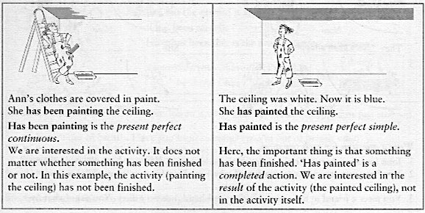

 | 

She’s been eating cakes. He’s eaten the whole cake. (Focus on completed action often with a quantity. How much/many?)

N.B. No state verbs

N.B. Long and short action verbs
What’s wrong with the following sentence?

I’ve been cutting my finger.

Note – If the continuous is possible, then it’s preferable.

